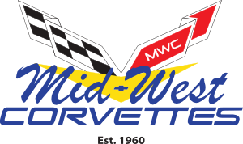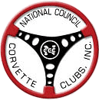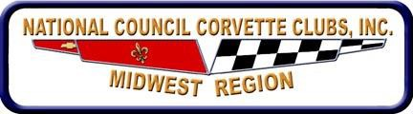

MID-WEST CORVETTE CLUB PRESENTS
Al Fiscus Memorial Spring Rallye Sunday, April 19, 2026
Eriksen Chevrolet – 325 1st Avenue East – Milan, IL 61264

Type of Rallye Event
Poker Sanction MW-054-001 Gimmick Sanction MW-054-002 Gimmick Sanction MW-054-003 Gimmick Sanction MW-054-004

Entry Fees
Day of Event $20.00 per Event or all 4 Events $70.00
Pre-Registration $60.00 for all 4 Events if paid by April 11, 2026 Registration Open 8:00 AM to 9:00 AM (CST)
Drivers Meeting 9:15 AM
First Car Out 9:30 AM

Event Chairman Contact Information
Jeff Bellmyer
(309)781-4801 (cell)
jeffbellmyer@gmail.com

This event will be held rain or shine
PRE-REGISTRATION FORM – Must be received by April 11, 2026
Make checks payable to: MID-WEST CORVETTES FOR $60.00 (ALL FOUR EVENTS) Please send to: Mid-West Corvette Club
PO Box 111
Milan, IL 61264

Non NCCC members not insured by NCCC

DRIVER: |  | NAVIGATOR:
DRIVER NCCC#: |  | NAVIGATOR NCCC#:
CLUB: |  | VEHICLE TYPE:
EMAIL: |  | PHONE #:

MAP AND EVENT INFORMATION:
Eriksen Chevrolet 325 1st Avenue East Milan, IL 61264

