Hall of Honor – Denny Waddell
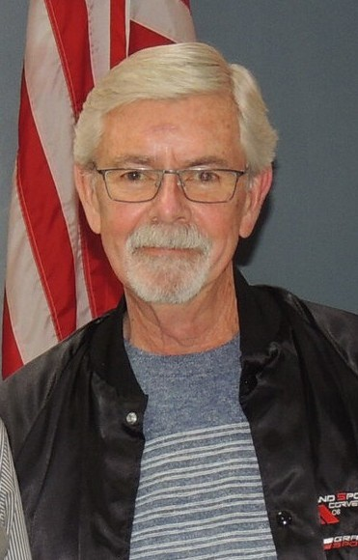
Denny Waddell 1965-present.
Denny, our club records show you joining MWCC in 1965.
- What was your first Corvette?
It was a 1962 dark red convertible.

- Do you remember where you purchased it at?
Yes, I was selling cars at Mill’s Chevrolet when I saw it. I sold my 65 Super Sport and bought the 62 Corvette.

- During the muscle car years, what made you decide to get a Corvette?
I was 22 years old and had wanted one for years.

- In 1965, the MWCC was only five years old. Why did you join?
Mill’s Chevrolet was the MWC club sponsor and I was chosen as the dealership’s representative. To be in the club you needed to have a Corvette. I hadn’t owned a Corvette, so Mills supplied me with one until I bought my own. After leaving Mills to sell for Warren Chevrolet, the club about folded. I was responsible for having Warren’s take over the sponsorship. As time passed, I left Warren, selling cars for Eriksen’s Chevrolet. Again, the club floundered and Eriksen’s stepped in to sponsor the club with me as the dealer rep.

- Other than president, have you held any other board positions?
Pretty much all of them. President, vice president, treasurer, and secretary.

- Over the years, how many Corvettes have you owned?
40 so far! Being in the auto sales business, I bought and sold a lot of Corvettes.

- Which Corvette was your favorite?
I’d have to say the C7 was my favorite.

You recently sold your last Corvette. As a Lifetime member you will always hold a special and honored position with the Mid-West Corvettes Club. Thank you, for your many years of service Denny.

Highlights of the year 1965.
1965 was a pivotal year marked by a major escalation of the Vietnam War with the arrival of U.S. troops, the signing of the Voting Rights Act following the Civil Rights Movement’s Selma marches, and significant advancements including the first spacewalk by Alexei Leonov. Other notable events include the assassination of Malcolm X, the completion of the St. Louis Arch, and the debut of A Charlie Brown Christmas. And how could we forget the introduction of the Pillsbury Doughboy and SpaghettiOs?

