Hall of Honor - Randy & Jane Huber
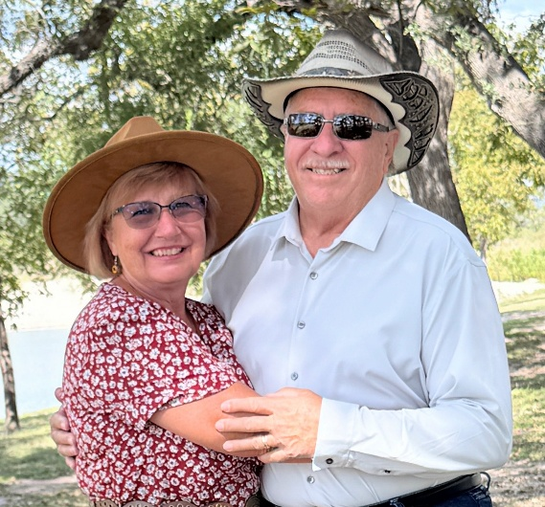
2000- present
What was your first Corvette? a 1971

Purchased? Randy found it buried in a snow bank in Dubuque, IA in March of 1988, purchased from a private party and re-did the interior and exterior.

Why did you buy your first Corvette?
Randy: I fell in love with a 1963 split window at 12 years old and vowed to own one someday.
Jane: I was always around cars, brothers, boyfriends and those C3's always turned my head when in High School!

Why did you join MWCC?
Attended a greet and meet club picnic in Bettendorf and everyone was so welcoming.

Board Positions held:
Randy: President for 7 years (2010-2018, with one skipped year), Finance committee chair (when club was broke and they got us back in the green) Chaired the 50th Anniversary Celebration Committee and event.
Jane: Secretary, I think for 5 years, Membership for 1 year & VP for 3 or 4 years. Contributed Club graphics, logos & banners and lots of photos.
Together we created Vettes on the River and chaired the committees.

How many Corvettes have you owned?
Over the years we have owned 10 Corvettes.
Our favorite is our current 2017 Grand Sport Coupe. Top Speed for Randy 166 mph at Big Bend High Octane Fest. Top speed for Jane 149 (there was a mustang in front of me) at the same Big Bend Octane Fest where there are lots of wide-open roads!

We enjoy members stopping in and seeing us when traveling around Texas, all are welcome to give us a call (even if we've not met yet) and meet up for lunch or come to our home. Also, there are great roads down here...look up "Twisted Sisters" (Ranch Roads 335, 336 & 337). It'd be a lengthy trip for all y'all, but we can show you around SA, TX and area!

Vettes On The River.

Created to have interaction with other Corvette clubs. First year was with the Cedar Rapids Corvette Club and we met in the Amana Colonies and had 23 Corvettes. Our last year of chairing it was in 2018 due to our move to San Antonio, TX for Randy's work. That year, we filled LeClaire, IA Levee, created a ramp so MWCC members parked together on the grass at the south end and we filled up Wisconsin Street hill up to the top and a couple side streets for a total of 634 Corvettes. Needless to say, it grew. We still miss MWCC friends and events and hosting VOTR! I, (Jane) had continued designing the VOTR t-shirts until last year when I was not able due to my son's wedding in CA and travels. We have belonged to the Texas Corvette Association and Alamo Area Corvette Club (both over 300 members) but find they don't measure up to MWCC, you've got something special there in the QC.

VOTR write up that was in the 2016 Winter Blue Bars written by Randy Huber.
Vettes On The River 2015. I believe it was around mid-day on August 29th of this year. I was sitting at a picnic table on the LeClaire, Iowa Levee outdoor pavilion. The morning light rain had finally left the area and I was enjoying the live music, my pork tenderloin sandwich, all the Corvettes on display, and feeling very proud to be a member of the host club Mid-West Corvettes Inc. An officer from one of the other clubs in attendance came up to me and asked a simple straight forward question.
“What’s your secret?” How do you put on such a successful Corvette car show and fill the Levee with 262 Corvettes from 35 regional Corvette clubs and non-affiliated Corvette owners. (It’s no secret that rain and Corvettes usually don’t make for a great car show turn-out.) So, I turned to my Corvette counterpart and had a quick answer. You’re surrounded by it!!! I really didn’t have to expound on my answer as I could see he knew what I was talking about as soon as I said it.
In my opinion LeClaire, Iowa has one of the best locations to have a car show. One would have thought they had built the Levee for that specific purpose. The proximity of the Levee to Mississippi River is literally a few feet away and the views are unobstructed and magnificent. As you turn away from the river, you can see all backsides of the Merchant stores and Restaurants which typically have decks for patrons to sit and enjoy the Levee from an elevated perspective. The main street is a short walk from the Levee so you can park your Corvette and visit a River City that can satisfy hard core shopaholics, and you can choose from a wide variety of dining establishments. But the location alone would not have to be as perfect if it were not for the City Officials, the Levee Board, and the merchants. They are “all-in” lock step partners in their support of the event.
But like many car shows, it had to start somewhere and ours started in 2010. My wife, Jane came to me and observed that our Mid-West Corvettes Club, while doing a great job of creating charity events to raise funds for our local Children’s Charities, did so on our own and mainly kept to the confines of the club. She suggested we attempt to interact with another Corvette clubs and share each-others successes and ideas. I said “go for it” and she contacted the Cedar Rapids Corvette Club and they were all for having a social meeting. Each club got as many of their members as they could together and we each planned our own drive-outs that would end up at the Amana Colonies, Iowa for lunch and a “meet and greet”. Our club had 9 cars and the Cedar Rapids Corvette Club had 14 cars. Needless to say, we had a great time, shared our ideas, and admired each other’s Corvettes. Parting ways, both clubs felt good about the interaction.
The following year, the Cedar Rapids Club invited us to the Grand Harbor in Dubuque, Iowa for a car show with our two clubs. They put on a great show and this time our Mid-West Corvettes Club came with 44 cars and Cedar Rapids Club brought 22 cars. Again, we had a great time and dined with our new-found friends joined by our passion for the Corvette. During one of our conversations, someone in the Rapid City Corvette club said “this is like Vettes on the River” and car show name was born.
In 2012 It was the Mid-West Corvettes Club’s (MWCC) turn to host the show. We created a core committee of 12 and started to work on the event in March of 2012. This was our first attempt at a car show larger than our club, but we learned a lot from the Cedar Rapids Corvette Club. We decided to locate our “Vettes on the River” event in LeClaire, Iowa and the setting would be on their Levee. We also decided to expand our concept of increasing Corvette club interactions and invite 18 Corvette clubs around the region. To generate our Corvette club invite list, we used the Blue Bars Corvette club listing and did some additional searching on the web. On July 7th 2012 Mid-West Corvettes Club put on our first Vettes On The River (VOTR) Corvette Car Show. The sun was shining, the humidity was high, and the temperature with the heat index was 108 degrees. All I kept saying all day “they just kept coming”. At the end of the day, we had 247 Corvettes participating and we knew we had something special.

