Hall of Honor - Al Fiscus
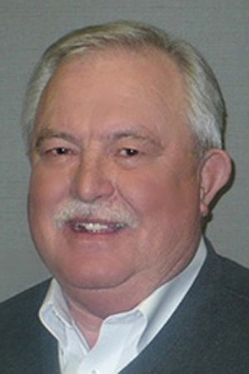
Allan J. “Al” Fiscus
12/28/1947 – 12/17/2021
The words of Al Fiscus, as taken from the Mid-West Corvettes Club 60th anniversary brochure, by Jennifer DeWitt.

“Being an MWC member has been a grand journey of 47 years as a member,” said MWC Governor Al Fiscus, (Life Member), who recalls being 10 years old when he saw his first Corvette – a ‘57 – drive up to his neighbors’ house in Hastings, Neb. “The sight and sound of that Corvette was like something out of a movie that I never forgot.” At the time, the young boy could not know that he would buy his own Corvette at the age of 19 from Mills Chevrolet salesman Denny Waddell, another MWC Lifetime Member. Nor could he have imagined it would be the first of more than 50 Corvettes he has owned over his lifetime. Fiscus, who joined the MWC when he got the keys to his first Corvette, said “As the saying goes ‘We came for the cars and stayed for the people.’”
Al served in every board position with the Mid-West Corvettes Club. His auto sales career included 38 years with Eriksen Chevrolet. 29 consecutive years as Top Sales professional.
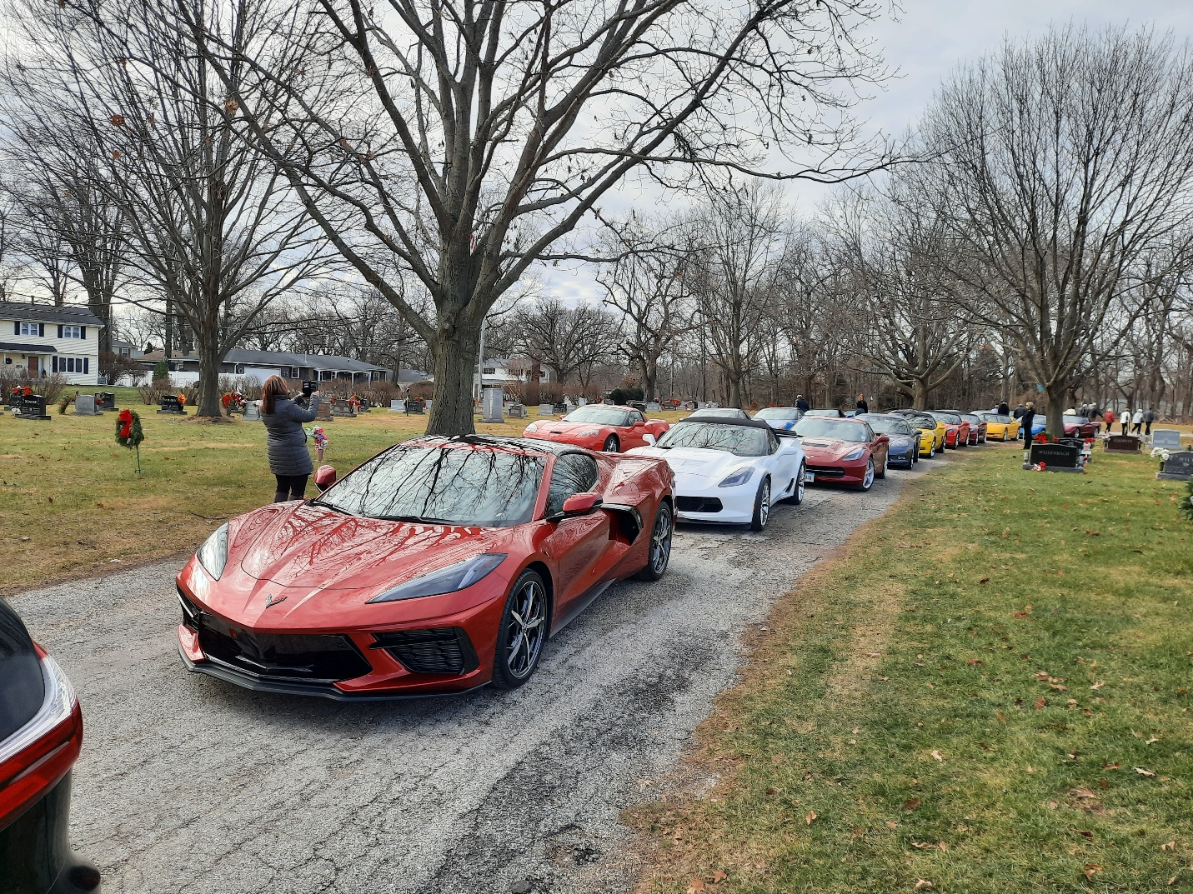
On a cold December day, Mid-West Corvette Club members joined to see Al off.

